

Mayor Pro Tem Anne Clutterbuck
Houston City Council Member, District C

Chair, Budget & Fiscal Affairs Committee
Board of Directors, Houston Galveston Area Council

Rhonda Smith, Executive Director
Houston Municipal Employees Pension System
1111 Bagby, Suite 2450
Houston, Texas 77002

Dear Executive Director Smith:

A meeting of the Budget and Fiscal Affairs Committee of City Council is scheduled for October 5, 2010. A review of the pension benefits the City provides to its employees will be included on the agenda for that meeting.

As Chair of the Budget and Fiscal Affairs Committee, in order to prepare for the meeting, I request that you provide me with a list of all members of HMEPS who began receiving a regular (non-disability) retirement during the 12 month period ended June 30, 2010, indicating the following:

- Age at retirement
- The initial annual annuity amount expressed as a % of annual base salary immediately prior to retirement (no dollar amounts)
- The DROP account balance at retirement expressed as a multiple of annual base salary immediately prior to retirement (no dollar amounts)

Please note that to respect the confidentiality of individual information, I am not asking for name, years of service, dollar amounts of benefits or any other means of identifying the individual member.

I would appreciate your cooperation in furnishing this information by Friday, September 24, 2010.

If you have any questions, please call my office at 832-393-3004.

Regards,

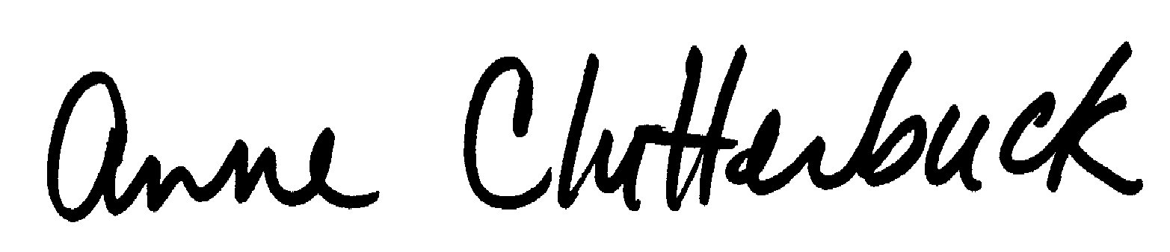

Anne Clutterbuck

Cc: Sherry Mose, Chairman of the Board

Telephone (832) 393.3004 • Fax (713) 437.6901 • P.O.Box 1562 Houston, TX 77251-1562
900 Bagby, 1st Floor, Houston, TX 77002
districtc@houstontx.gov

